Internal Auditor
Budget: | Up to £50k | Function: | Risk and Assurance
Line Manager: | Meghan Paramour / Kate Taylor | Direct Reports: | None
Our Vision
For over 150 years, Simplyhealth has improved access to UK healthcare, long before the NHS existed. Today, as a certified B-Corp, we continue to modernise in ways that matter deeply to our c.2.5 million members, our customers, and our people.
Our purpose is simple and ambitious: to improve access to healthcare for all in the UK. Through affordable health and dental plans, we help people manage their everyday healthcare needs and live healthier lives.
We have ambitious plans to play a much broader role in UK healthcare as a health solutions provider, supporting the NHS through the provision of outpatient support. This will be achieved though expanding both our customer base and service offering, to ensure it has the greatest possible impact on access to healthcare in the UK.
Our vision
With growing pressure on the NHS, Simplyhealth’s products are more essential than ever. But our ambition goes further: we aim to democratise healthcare by making it more affordable and accessible for everyone in the UK
By 2030, Simplyhealth Group will be the UK’s most trusted health navigation and access marketplace that delivers easy to find, affordable services, including our own provision of primary care and financial products that measurably improves outcomes for employees, individuals and providers.

What we do

Simplyhealth is the UK’s leading health plan provider. Its health plans help customers claim cash back for everyday outpatient healthcare treatments carried out by dentists, opticians, physiotherapists, chiropractors, and many more. The plans increasingly also help individuals navigate a complex health care landscape and provide access to care through clinically validated healthcare partners.
Simplyhealth helps employers to improve the health and wellbeing of their employees through its My Health service which gives access to GP services, a 24/7 advice and counselling helpline and a wealth of health advice and information.
It is also the UK’s leading dental payment plan provider. Its Denplan payment plan was developed almost 40 years ago by dentists, for dentists, and continues to support dental customers in budgeting for preventative dental care and to avoid future problems. Denplan also provides an extensive range of support services to help dentists run and grow their practices.
As a company limited by guarantee with no shareholders, Simplyhealth reinvests its profits to benefit its customers and communities, now and in the future.

Our Group strategy
Simplyhealth Group is building the UK’s trusted health access platform, one place to find, book and pay for care, with clear prices, quality you can trust, and optional, fair point-of-need payment options. We focus on what matters most: fast access, less friction, and measurably better outcomes. By 2030, our aim is to be the most trusted way to navigate and access care across the UK, strengthened by our own provision of primary care where it materially improves speed, experience and value. To help customers easily find and access the help they need we also see opportunities for far greater awareness raising and cross-selling across our lines of businesses.
For employers, we keep their workforce healthy, productive, and engaged by offering affordable, scalable healthcare solutions that reduce absenteeism, support mental health, and deliver measurable ROI by tracking retention, speed of access, and reduced absence.
For working adults using the platform, we aim to make healthcare feel simple again. From the first click, they see real options, real prices and clear next steps, and they can book and pay their way. Helping them take control of their health without the wait, confusion, or financial strain. We see capitation, insurance and financing in the context of our dental patients, all being available in a one-stop shop, offering a simple customer journey. It’s care that fits life, not the other way around.
Our strategy is focused on helping people to Find the care they need and Fund the care they need affordably so ultimately they can Flourish:
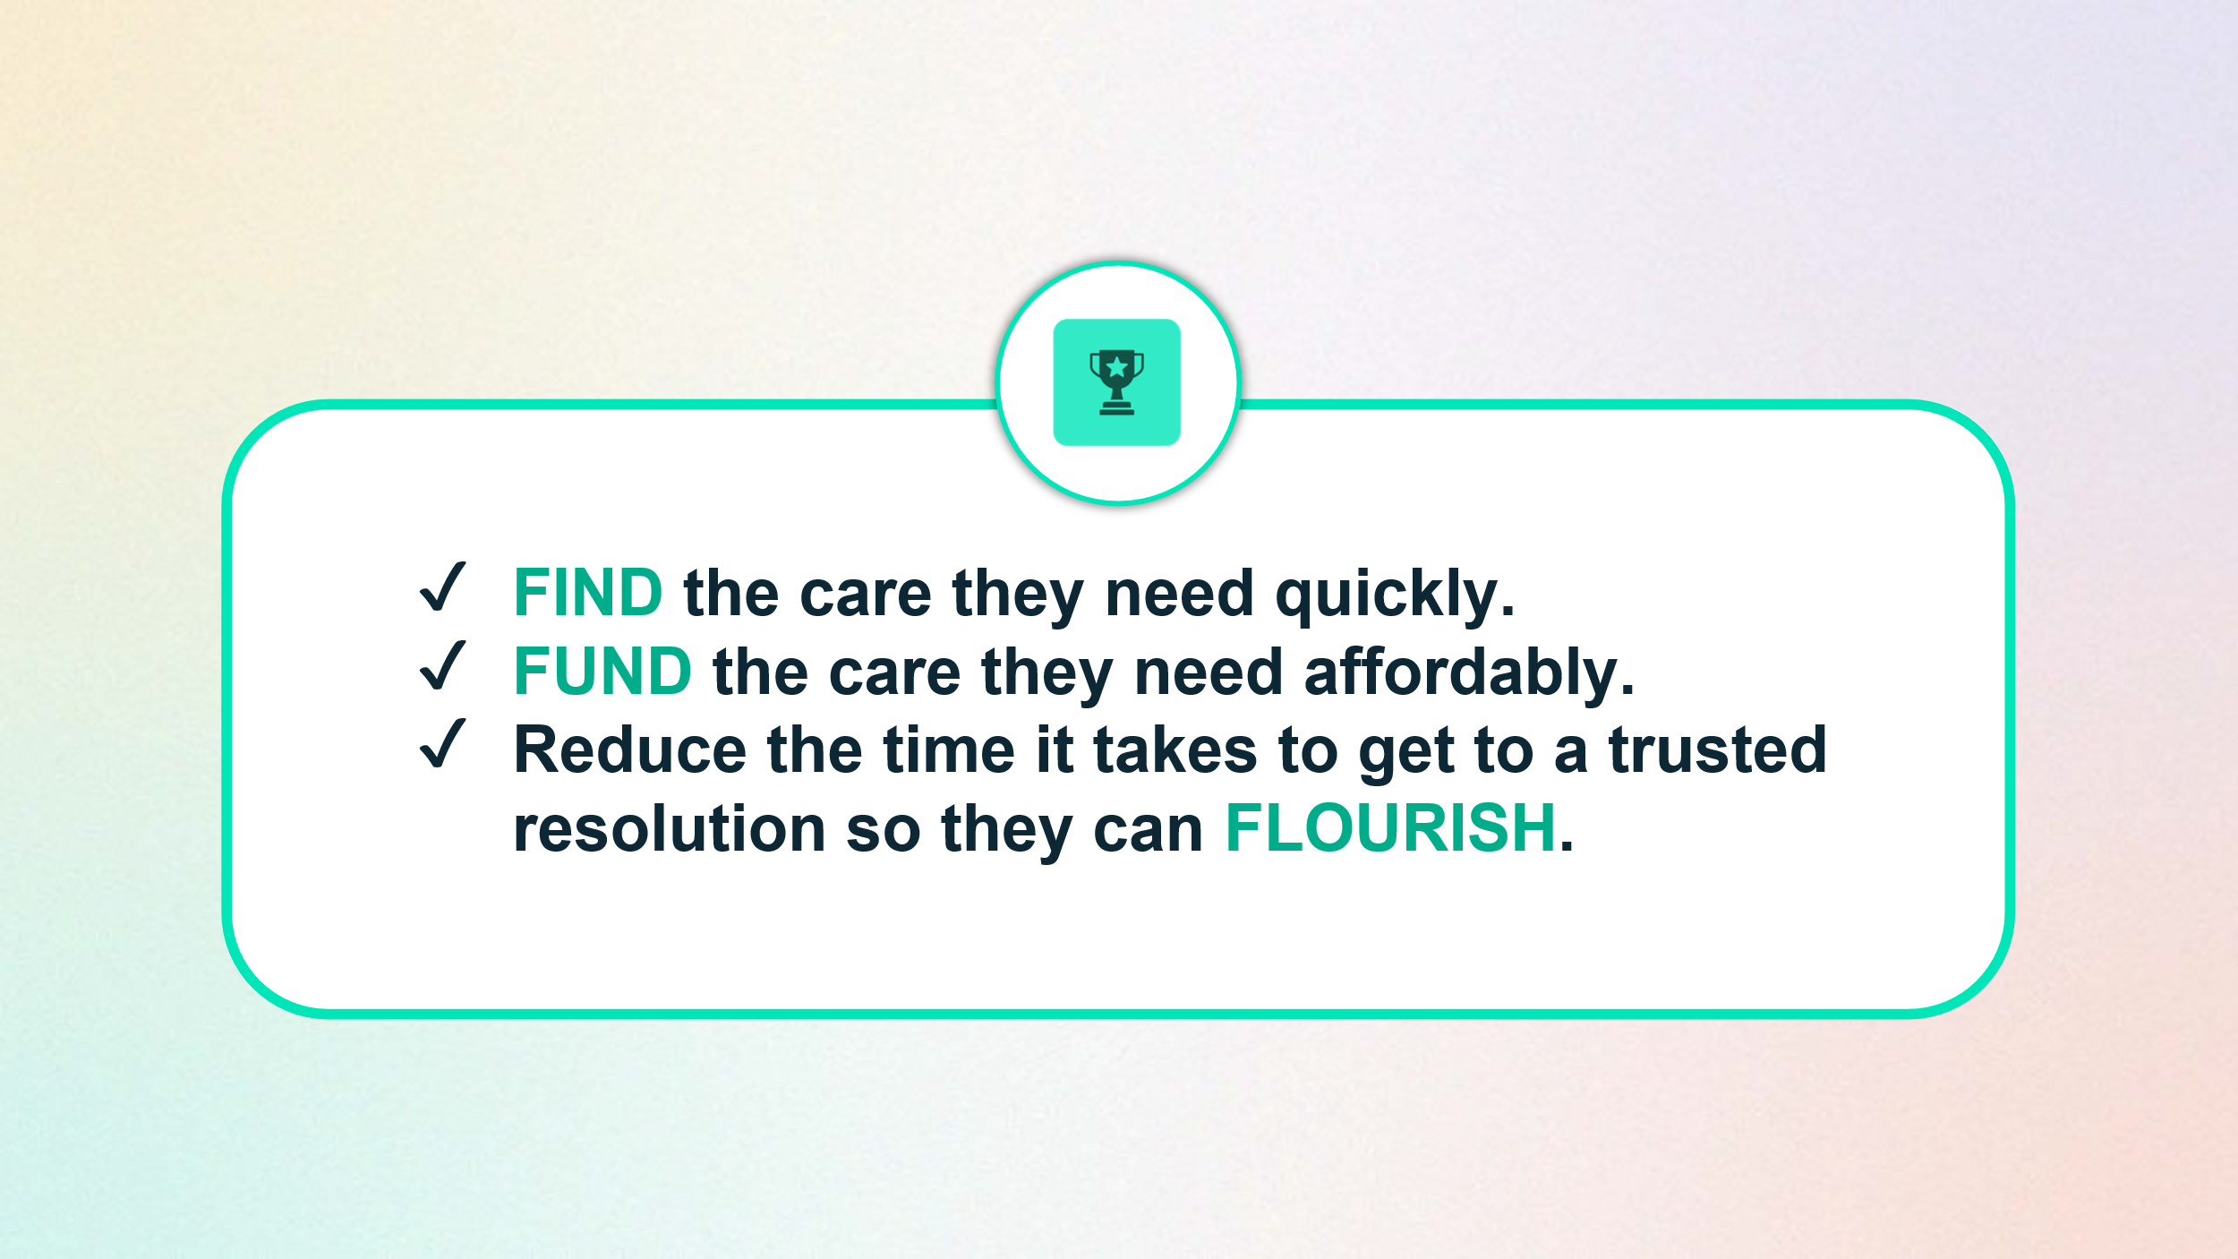
To achieve this, Simplyhealth has embarked on a radical transformation journey. With a trusted brand and a strong heritage in healthcare, it is uniquely placed to help change the landscape of healthcare in the UK.
- The scale of this ambition and transformation is significant and requires energetic, ambitious, and digitally minded leaders to deliver against it.
Your Role
The Internal Audit Function provides assurance that the organisation is effectively delivering on its strategic plan and has effective governance and controls in place to ensure the plan is delivered in line with risk appetite.

Reporting into the Head of Internal Audit, the Internal Auditor will be responsible for the delivery of audit assignments and supporting the wider audit team responsibilities, as required. This is a hands on role, where the auditor will take ownership of audits end to end, working closely with the senior stakeholders across the business.

Working alongside a small internal team supplemented with co-sourced skills from an external 3rd party, the Internal Auditor will be a respected and trusted member of the audit team, supporting the Head of Internal Audit in providing assurance to the Chair of the Audit Committee and the Board, to support their oversight of the business.

Your Responsibilities & Accountabilities:
- Support the Head of Internal Audit in the delivery of the risk based Internal Audit Annual Plan, in line with the International Professional Practices Framework and Internal Audit Methodology. This includes delivery of end to end audit reviews from audit planning through to final reporting.
- Identify key risks, evaluate control frameworks and highlight areas for improvement.
- Deliver clear, concise audit reports for senior leadership.
- Provide pragmatic recommendations to enhance processes, controls and operational effectiveness.
- Track and follow up on agreed management actions, ensuring timely implementation.
- Build strong working relationships across the business and with senior stakeholders.
- Assist as required in preparing materials for governance forums and committees.
- Contribute to wider innovation of the audit team, through supporting the delivery of the Internal Audit Strategy.
- Manage your own personal development, in line with objectives agreed as part of the PDR process, and other development needs identified during the year, to lead to increased performance.
- Work in accordance with professional standards and the Code of Ethics relevant to the profession and practice of internal auditing, to promote ethical behaviour and acting with integrity.

Key Experience and Skills:
- A sound understanding of risk, business process and key controls in a financial services environment to assess, report on and make suggestions for improving key operational and financial controls.
- Can demonstrate the ability to work independently and manage multiple audits simultaneously.
- Displays evidence of an inquisitive, enquiring and analytical mind with the capability to make appropriate decisions which are underpinned by a sound understanding of the business and eye for detail.
- Commercially aware with the ability to negotiate and influence; is comfortable challenging the business, tactfully and assertively.

Our Culture and Values
We need to act with courage and curiosity to unlock opportunities for customers, colleagues, and communities. We operate with trust and kindness delivering what customers need and supporting colleagues to be their best. We live our All together healthier ethos, focusing on self-care and nurturing relationships.

Simplyhealth’s cultural ambition can be summarised as doing the right thing: by its customers, its people, its communities and our planet. It seeks individuals who have passion and energy, who believe in a commercial agenda but who also believe the outcome of Simplyhealth’s commercial endeavours can lead to a better life and a healthier planet.
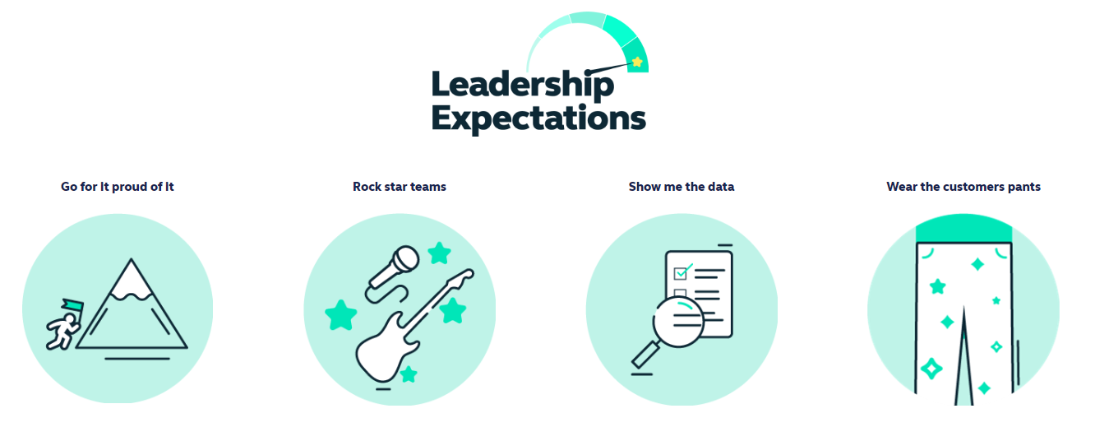
Health and access to healthcare have never been more important. With this comes endless exciting possibilities for innovation and growth. The market is evolving quickly, and we’re committed to leading-edge solutions our customers expect and deserve, now and for generations to come.

By reinventing ourselves, we will reach more customers, expand access to affordable healthcare, and unlock our growth potential. This next chapter is about transformational change.

To make this a reality, we will challenge our ways of working while keeping the customer at the heart of everything we do.
Work Arrangements
- This is an Andover based role, with a requirement to regularly attend meetings at our Hampshire based head-office but we have a ‘smart working’ policy with flexible remote working.
- Must be independent and demonstrate the strength of character to remain so.

