Senior Customer Growth & Lifecycle Marketing Manager

Job Family: | Marketing | Line of Business: | Healthplan and On Demand
Reports to: | Head of Member Engagement | Team size: | Three, supported by external agency partners
Our Purpose & Vision
For over 150 years, Simplyhealth has improved access to UK healthcare, long before the NHS existed
Today, as a certified B-Corp, we continue to modernise in ways that matter deeply to our c.2.5 million members, our customers, and our people.

Our purpose is simple and ambitious: to improve access to healthcare for all in the UK
Through affordable health and dental plans, we help people manage their everyday healthcare needs and live healthier lives. With NHS pressures and the cost-of-living crisis making access to care harder, our mission is more critical than ever.
We have ambitious plans to play a much broader role in UK healthcare as a health solutions provider, supporting the NHS through the provision of outpatient support. This will be achieved though expanding both our customer base and service offering, to ensure it has the greatest possible impact on access to healthcare in the UK.

Our vision
With growing pressure on the NHS, Simplyhealth’s products are more essential than ever. But our ambition goes further: we aim to democratise healthcare by making it more affordable and accessible for everyone in the UK. By 2030, Simplyhealth Group will be the UK’s most trusted health navigation and access marketplace that delivers easy to find, affordable services, including our own provision of primary care and financial products that measurably improves outcomes for employees, individuals and providers.

What we do
Simplyhealth is the UK’s leading health plan provider. Its health plans help customers claim cash back for everyday outpatient healthcare treatments carried out by dentists, opticians, physiotherapists, chiropractors, and many more. The plans increasingly also help individuals navigate a complex health care landscape and provide access to care through clinically validated healthcare partners. Simplyhealth helps employers to improve the health and wellbeing of their employees through its My Health service which gives access to GP services, a 24/7 advice and counselling helpline and a wealth of health advice and information.

It is also the UK’s leading dental payment plan provider. Its Denplan payment plan was developed almost 40 years ago by dentists, for dentists, and continues to support dental customers in budgeting for preventative dental care and to avoid future problems. As a company limited by guarantee with no shareholders, Simplyhealth reinvests its profits to benefit its customers and communities, now and in the future.

Our Group strategy
Simplyhealth Group is building the UK’s trusted health access platform, one place to find, book and pay for care, with clear prices, quality you can trust, and optional, fair point-of-need payment options. We focus on what matters most: fast access, less friction, and measurably better outcomes. By 2030, our aim is to be the most trusted way to navigate and access care across the UK, strengthened by our own provision of primary care where it materially improves speed, experience and value.

For employers, we keep their workforce healthy, productive, and engaged by offering affordable, scalable healthcare solutions that reduce absenteeism, support mental health, and deliver measurable ROI by tracking retention, speed of access, and reduced absence.

For working adults using the platform, we aim to make healthcare feel simple again. From the first click, they see real options, real prices and clear next steps, and they can book and pay their way. Helping them take control of their health without the wait, confusion, or financial strain.

Our strategy is focused on helping people to Find the care they need and Fund the care they need affordably so ultimately, they can Flourish
Role Overview
Simplyhealth is investing in a significant transformation in how we drive growth through our existing customers across the lifecycle. With Accenture Song supporting us as our strategic partner, we are developing how we use customer data, CRM, content, creative, propositions and technology to deliver more relevant and effective customer experiences and deliver against our commercial targets.
As we broaden our approach to growth and lifecycle marketing, we're looking to add specialist expertise that complements the team's existing skills. This is a builder role — we need someone who is happy to shape what is required within the team and across the wider organisation to deliver sustainable growth.
As Senior Customer Growth & Lifecycle Marketing Manager, you will own agreed customer growth targets for On Demand product and existing customer base, driving measurable improvements in conversion, purchase, product adoption, cross-sell, renewal, customer lifetime value and revenue.
You'll move between strategy and hands-on marketing: using customer insight to identify an opportunity, developing the proposition, shaping the creative idea, writing or refining the copy, defining the customer journey and working with the CRM team to deliver, test and optimise it.
CRM and Salesforce Marketing Cloud will be an important part of the role, but this is not a pure CRM role. We need someone who combines strong commercial and creative thinking, and can turn customer insight and data into strategy, compelling propositions, content, creative and customer journeys that drive growth across the lifecycle and across broader customer channels.
As there isn’t a fully formed growth function waiting for you, you'll have a genuine opportunity to help build how growth and lifecycle marketing works at Simplyhealth in the future.

Key Responsibilities & Accountabilities:
Customer understanding
Develop a strong understanding of customers and our products — their needs, motivations and behaviours — and use this to identify opportunities for growth and better customer experiences.

Growth and lifecycle marketing
Own agreed customer growth targets across the funnel, driving measurable improvements in conversion, purchase, product adoption, cross-sell, renewal, LTV and revenue.

Forecasting, measurement and commercial planning
Work with finance to use performance data to forecast likely outcomes, identify risks to target and recommend interventions to close commercial gaps. Establish robust approaches to measure the incremental impact of marketing activity and focus investment on the opportunities delivering the greatest commercial return.

Experimentation and optimisation
Own a prioritised test-and-learn programme across propositions, audiences, messaging, creative and customer journeys. Use experimentation and performance data to identify what drives incremental growth, improve conversion and scale what works.

Customer journey and conversion
Identify friction and opportunities across the customer journey and work with digital, product and CRM teams to improve conversion, customer experience and commercial performance.

Creative and content direction
Bring strong creative judgement to marketing activity, ensuring that messaging and content are distinctive, relevant and appropriate for the customer. Balance creativity with evidence and performance data, ensuring creative work is designed to drive both customer value and commercial outcomes.

Building new marketing capabilities
Identify where existing processes, capabilities or ways of working aren't sufficient, and build better ones. This could include new segmentation, journeys, campaigns, processes, tools, frameworks or initiatives.

Cross-functional commercial delivery
Work closely with teams across the organisation to build the lifecycle marketing capability Simplyhealth needs to drive revenue and growth. Build strong relationships across CRM, digital, product, data, finance, proposition and external agency partners, ensuring teams are aligned around clear customer and commercial outcomes.

Key Experience & Skills:
You will bring a combination of:
- B2C growth marketing background, with a strong understanding of what customers need, what drives behaviour and what creates commercial value.
- Proven experience owning customer growth targets, working with finance teams on forecasting and improving performance across the funnel.
- Expertise in translating customer and commercial opportunities into impactful messaging, journeys and campaigns.
- Exceptional creative judgement and taste, with the ability to combine analytical rigour, creativity and compelling content.
- A great writer with strong attention to detail.
- Deep growth and lifecycle marketing (CRM & performance) experience, with Salesforce Marketing Cloud, Braze or other automation software.
- Strong cross-functional collaborator, able to work effectively across teams and partners.
- Demonstrated impact in ‘building’ new processes, ways of working and initiatives.
Nice to have
- Experience in healthcare, financial services, insurance, membership or another regulated/customer relationship-led environment.

Our Culture and Values
We need to act with courage and curiosity to unlock opportunities for customers, colleagues, and communities. We operate with trust and kindness delivering what customers need and supporting colleagues to be their best. We live our All together healthier ethos, focusing on self-care and nurturing relationships.

Simplyhealth’s cultural ambition can be summarised as doing the right thing: by its customers, its people, its communities and our planet. It seeks individuals who have passion and energy, who believe in a commercial agenda but who also believe the outcome of Simplyhealth’s commercial endeavours can lead to a better life and a healthier planet.

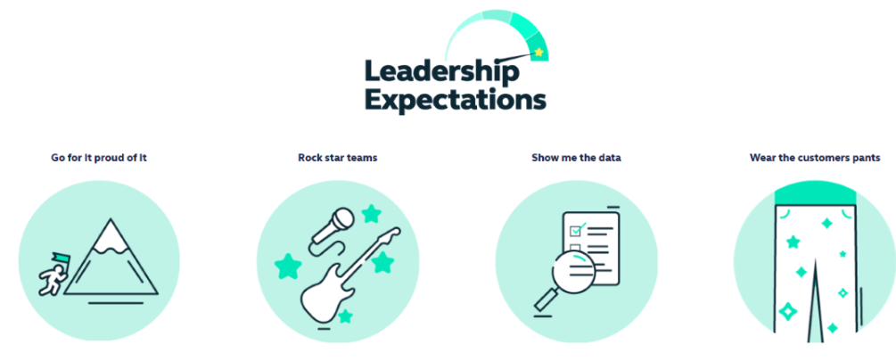
Health and access to healthcare have never been more important. With this comes endless exciting possibilities for innovation and growth. The market is evolving quickly, and we’re committed to leading-edge solutions our customers expect and deserve, now and for generations to come.

By reinventing ourselves, we will reach more customers, expand access to affordable healthcare, and unlock our growth potential. This next chapter is about transformational change.

To make this a reality, we will challenge our ways of working while keeping the customer at the heart of everything we do.
- This is an Andover based role, with a requirement to regularly attend meetings at our Hampshire based head-office but we have a ‘smart working’ policy with flexible remote working.
- Some UK travel and overnight stays.
- Reasonable role and task flexibility expected given the seniority of the role.
- May be required to lead other business activities or projects in other parts of the Simplyhealth Group.

