Social Impact & Community Enterprise Manager – Food Insecurity
(6-month secondment)

Budget oversight: | £500k | Function: | ESG (Risk & Assurance)
Line Manager: | Senior Sustainability & Resilience Manager | Direct Reports: | 0
Our Vision
Simplyhealth has a simple, yet powerful purpose: To improve access to healthcare for all in the UK.

We don’t have shareholders, and we reinvest our profits back into healthcare, for the good of the wider healthcare system, our customers, and our community. Working with nearly 8,000 businesses, and a further 4,200 dental practices, we have 2.5 million members benefitting from our health and dental payment plans and on demand services. We are the UK’s largest health plan provider and the first to be B Corp certified.

A place-based approach for reducing health inequalities

Health is not just about the length of life we live, but also the quality of the life. The gap in healthy life expectancy (years lived in good health) between the most and least deprived areas of England is around 19 years for both males and females.

The extra costs to the NHS of health inequalities have been estimated as £4.8 billion a year, from the greater use of hospitals by people in deprived areas alone. Health inequalities reduce employment and productivity, which has a cost for the national and local economy. Health inequalities are not caused by one single issue, but rather a complex mix of environmental and social factors which play out in a local area, or place. This means that local areas have an important role to play in reducing health inequalities.
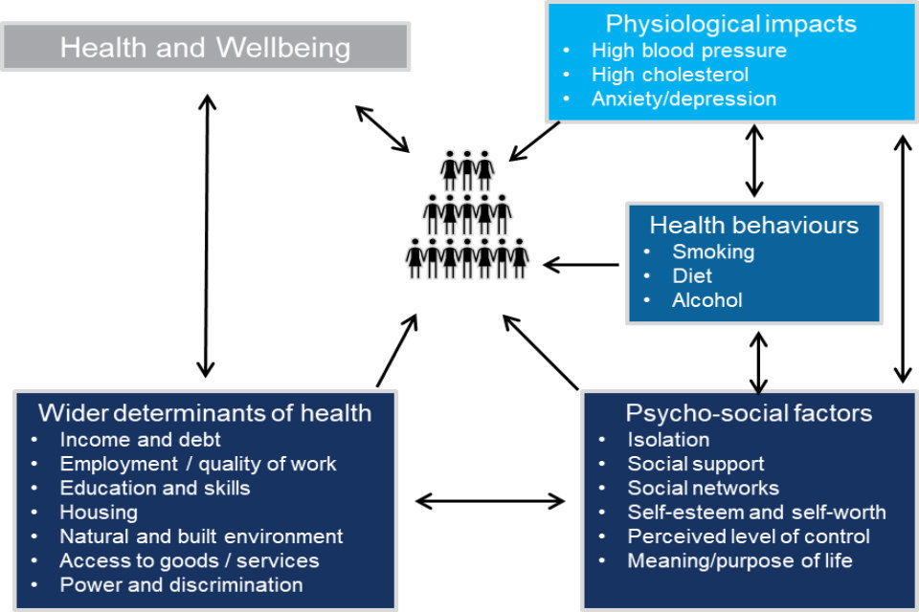

Using an adapted Labonte model (see above), showing how wider determinants of health interact with other factors and their impact on health and wellbeing, we have identified an opportunity in Hampshire for an investment and intervention that focuses on treating the ‘place’, not just the ‘people’. This is an important distinction, because acting on only one factor alone is likely to provide a partial and incomplete response to the situation.

Hampshire & Food Insecurity

Food insecurity—defined as the inability to access sufficient, affordable, and nutritious food—has become an increasingly prominent issue across the UK. Nationally, structural pressures such as low incomes, rising living costs, and welfare inadequacies continue to drive hardship.
Although Hampshire is often perceived as relatively affluent area, emerging data shows that food insecurity is present, growing, and unevenly distributed, reflecting broader national and regional trends.
Across the UK, food insecurity has reached historically high levels:
- Around 14.1 million people (1 in 6 households) experienced food insecurity in 2024. [trussell.org.uk]
- Approximately 7.5 million people (11% of the population) lived in food-insecure households in 2023/24. [commonslib...liament.uk]
- Food insecurity disproportionately affects children (33% in poverty) and lone-parent families (46%). [jrf.org.uk]
- Individuals referred to food banks often have around £104 per week after housing costs, far below what is needed to meet basic living standards. [hart.foodbank.org.uk]
- The Trussell Trust identifies food insecurity as fundamentally an income problem, not a supply issue. [rsnonline.org.uk]

At a regional level, Hampshire shows patterns typical of mixed rural–urban economies, where:
- Food insecurity can be less visible but still significant, particularly in rural or semi-rural communities with limited access to services. [rsnonline.org.uk]
- Research indicates measurable levels of food hardship in the county—for example, in East Hampshire:
  - 2.96% of adults experienced hunger
  - 7.91% struggled to access food
  - 8.35% worried about food availability [feedingbritain.org]

Recent data from the Trussell Trust network shows that in 2023/24, 9,493 emergency food parcels were distributed across the Test Valley area alone. This equates to food support for thousands of households annually. Trends show a significant increase in demand over the past decade and sustained growth even after the peak of the COVID-19 pandemic:
- 2017/18: 4,954 parcels
- 2019/20: 6,059 parcels
- 2023/24: 9,493 parcels [hampshirec...icle.co.uk]

Our opportunity to make a difference
Food insecurity in Hampshire and Test Valley reflects a wider national crisis but has distinct local characteristics. While the area benefits from relative affluence overall, growing food bank demand and evidence of hidden deprivation highlight significant unmet need.

Key conclusions:
- Food insecurity is increasing, not declining, despite easing inflation.
- It is structurally driven by low incomes and high living costs, rather than temporary shocks.
- Children, low-income households, and rural residents are most affected.
- Local support systems (food banks and pantries) are essential but reactive rather than preventative.

Addressing the issue will require:
- Strengthening incomes and financial resilience
- Improving access to affordable food
- Targeting hidden deprivation in rural communities

The role
We are seeking an experienced, entrepreneurial social impact leader to design, launch, and lead a new community-focused initiative addressing food insecurity and wider determinants of health. This role will establish and operationalise a new Community Interest Company (CIC), working closely with local communities, partners, and funders to deliver a sustainable, high-impact solution.
Inspired by leading models such as The Felix Project and Cook for Good, the successful candidate will combine strategic vision, commercial acumen, and deep empathy to create a scalable and community-led response to food poverty across Hampshire and wider determinants of health.
Your Responsibilities & Accountabilities:
1. Venture Creation & Strategy
- Lead the end-to-end development of a new CIC focused on reducing food insecurity.
- Develop a clear vision, strategy, and operating model aligned with community needs.
- Conduct local needs analysis and stakeholder mapping to ensure a community-centred approach.
- Build a robust business case, including impact metrics and long-term sustainability plans (to be presented to Simplyhealth Group’s Board by December 2026).

If successfully Board approved, the six month FTC role will be extended with a multi-year investment, moving from business case approval to implementation and delivery, to include responsibility for:

2. Financial Modelling & Investment
- Develop detailed financial models, forecasts, and funding strategies.
- Identify and secure initial investment from grants, philanthropic sources, impact investors, and local corporate partners.
- Build a diversified income model (e.g. contracts, trading activity, fundraising).
- Ensure strong financial governance, monitoring, and reporting processes.

3. Partnerships & Ecosystem Building
- Identify, engage, and onboard key partners, including:
  - Food producers, suppliers, and redistribution organisations
  - Local authorities and community organisations
  - Charities, schools, and family support services
- Negotiate and manage strategic partnerships to ensure reliable food supply and effective delivery to those most in need.
- Position the organisation as a trusted, collaborative anchor within the local ecosystem.

4. Programme Design & Delivery
- Design and oversee delivery of impactful food programmes (e.g. cooking provision/packaging, food education/training, community kitchens).
- Ensure services are accessible, culturally appropriate, and responsive to local needs.
- Embed strong monitoring, evaluation, and learning frameworks to demonstrate impact.

5. Community Engagement & Safeguarding
- Work directly and sensitively with vulnerable individuals and families experiencing food insecurity.
- Foster a culture of dignity, respect, and inclusion in all interactions.
- Ensure safeguarding policies and practices are embedded and upheld.
- Co-create solutions with community members, ensuring lived experience informs delivery.

6. Leadership & Governance
- Recruit, lead, and develop a small, high-performing team.
- Establish governance structures appropriate for a CIC, including Board engagement.
- Provide regular reporting to stakeholders, funders, and partners.
- Champion the organisation’s mission, values, and impact externally.

Key Connections:
- Simplyhealth Group Board and ExCo
- Simplyhealth Group ESG team
- Local Community Voluntary Services (CVS)
- Local Food Partnership Networks
- Local charities and community groups
- Local Government (Test Valley Borough Council & Hampshire County Council)
- Local corporates (including food distributors and corporate funders)
- Local education settings e.g. secondary schools, colleges
- Local volunteers

Local is defined as within Andover, Test Valley and Hampshire.

Key Experience:
Essential Experience
- Significant experience (typically 7–10+ years) in social impact, non-profit leadership, or social enterprise.
- Proven track record of launching or scaling programmes, ventures, or community initiatives.
- Strong experience developing business cases, financial models, and securing funding/investment.
- Experience building and managing multi-stakeholder partnerships across sectors.
- Demonstrated success in delivering projects from concept to implementation.

Skills & Capabilities
- Commercial acumen combined with a strong social mission focus.
- Excellent project management skills with the ability to manage complexity and ambiguity.
- Strong financial literacy and confidence working with budgets and forecasts.
- Strategic thinker with hands-on delivery capability.
- Outstanding stakeholder engagement and influencing skills.

Personal Attributes
- Deep empathy and commitment to working with vulnerable communities.
- Sensitive, thoughtful, and inclusive approach to engagement.
- Entrepreneurial mindset – proactive, resilient, and solution-focused.
- Values-driven, with a strong commitment to social justice and equity.
- High levels of integrity and accountability.

Desirable
- Experience in food systems, food distribution, or food insecurity initiatives.
- Experience setting up or working within a Community Interest Company (CIC) or similar structure.
- Knowledge of safeguarding practices and working with families and vulnerable groups.
- Local knowledge and strong community networks.

Our Values
We’re living in extraordinary times…

Health and access to healthcare have never been more important. With this comes endless exciting possibilities for innovation and growth. The market is evolving quickly, so we need to ensure our customers have access to the leading-edge health solutions they expect and deserve, now and for generations to come.
By reinventing ourselves, we will reach more customers, giving them increased access to affordable healthcare and unlocking our growth potential. This next chapter is about transformational change for us.
This is our time to survive, drive and thrive…

This is our chance to get ahead and stay ahead. We will ensure our commercial success by moving into new areas of healthcare, and leading with preventative, breakthrough solutions. We will use innovative digital tools, embracing technology to create new partnerships and opportunities. We are passionate about helping every generation lead better lives and get the care they need in real time.
To make this a reality, we need to challenge our ways of working, whilst keeping the customer at the heart of everything we do. To really make a difference, it’ll take every single one of us across Simplyhealth to step up.

Our cultural movement...

To act with courage and curiosity, so we can unlock the opportunities to help customers, colleagues and communities. To operate with trust and kindness, working alongside customers, delivering what they need to live their best lives, as well as supporting colleagues as they strive to be their best. Spotlight our passion for All together healthier, focusing on self-care and nurturing relationships. We must ensure we are a strong team - one that’s able to build healthier lives for all. We each have an important role to play in this next chapter. Everyone has the freedom to innovate and make a difference for our customers. We need to act at pace and take on newer, braver, creative approaches. We shouldn’t be afraid to fail fast and learn quickly. By being curious and continually pushing ourselves and each other, we will find new and better ways.

Our Behaviours
Courage and Curiosity | Trust and Kindness | All Together Healthier
So we deliver profits for a purpose | Because our customers, colleagues and communities are at the heart of what we do | Enabling better health outcomes together
- We make bold decisions and take considered risks, with customer and commerciality front of mind.  - We make things happen and keep things simple.  - We always take the initiative and hold ourselves accountable for the delivery of great results.  - We ask questions and listen intently as every viewpoint and capability counts, and we have the courage to be honest and say what we think. | - We invest in relationships to build trust and rapport.  - We listen carefully always trying to find ways to add value.  - We treat each other with care, compassion and kindness, celebrating and embracing differences.  - We strive to make a difference in society, unlocking opportunities for those in need. | - We help every generation take control of their health.  - We start with self-care so we can show up at our best, every day.  - We are full of energy and pride in what we do. We focus on self-development to learn and grow, so we can stay up to date and add value.  - We innovate and collaborate on our best ideas. Together, we can drive the changes that are needed to help our business grow, and help our customers live their best lives.

Working arrangements
Due to the unique nature of this role which Simplyhealth is commissioning on behalf of the local community, the following working arrangements are in place:

- The role will formally report into Simplyhealth’s ESG team (funded by Simplyhealth from charitable donations, on a Simplyhealth employment contract)
- We have a ‘smart working’ policy with flexible remote working. However, due to the nature of this community focused role and the relationship/networking requirements, we would expect you spend a minimum of 3 days per week working in the local community and where needed, from Simplyhealth’s head office in Andover.
- Some UK travel & overnight stays. Simplyhealth will cover reasonable BAU travel expenses
- Reasonable role and task flexibility expected given the nature of the role
- You will have access to all Simplyhealth equipment and access to core Simplyhealth systems
- You will also be provided with a Simplyhealth email address and access to Simplyhealth’s cloud-based systems

Why Join Us?
- Opportunity to build and lead a mission-driven organisation from the ground up.
- Direct, tangible impact on food insecurity in the local community.
- Work alongside passionate partners across the social impact ecosystem.
- Shape an innovative model with potential for scale and replication.

